A

FINAL REPORT

ON

**Forecasting Millennial Career Trends**

Submitted by,

**Summer Internship Project 2019**

**Shreyas Torgalmath**

SPOTLE LINK: <https://spotle.ai/ShreyasTorgalmath>

**What is the median salary that entry level employees expect grouped by stream?**

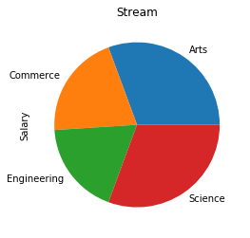

Stream

Arts 75000.0

Commerce 50000.0

Engineering 45000.0

Science 75000.0

By this we can come to know that,

* Science and arts expect Rs 75000
* Commerce expects Rs 50000
* Engineers expects Rs 45000

**2) Preferred city to salary expectation**

work city

Alipurduar, Siliguri 25000.0

All over India 25000.0

Americe 150000.0

Any Place 5000.0

Any city 150000.0

Any place except Hyderabad 45000.0

Any where 45000.0

Bangalore 45000.0

Bangalore 45000.0

Bangalore and Pune in India 50000.0

Bangalure 150000.0

Banglore 50000.0

Banglore ,chennai 75000.0

Banglore ,hydrabad 25000.0

Belgaum 45000.0

Bengaluru 112500.0

Bombay 150000.0

CANADA 45000.0

Canand 5000.0

Chandigarh 75000.0

Chennai 62500.0

Chennai Bangalore Pune 45000.0

Delhi 45000.0

Delhi , Mumbai , Pune , Bangalore 15000.0

Dharwad 5000.0

ERNAKULAM 75000.0

England 5000.0

Germany 150000.0

Goa 75000.0

Gurgaon 150000.0

...

Kolkata 75000.0

London 45000.0

Macau 150000.0

Madurai 45000.0

Mangalore 60000.0

Mostly Hyderabad else Any Metropolitan city 75000.0

Mumbai 45000.0

Mumbai 45000.0

Mysore 75000.0

New York 97500.0

NewYork 75000.0

Newyork 150000.0

Nodia 15000.0

Outside india 25000.0

Paris 45000.0

Puducherry 15000.0

Pune 60000.0

Secunderabad 50000.0

Suratkal 15000.0

Telangana 75000.0

UK 112500.0

US 60000.0

USA 150000.0

VISAKHAPATNAM 25000.0

Vishakhapatnam 150000.0

Washington 150000.0

ddd 25000.0

hyderabad 20000.0

hyderabad, pune, bangalore.... 25000.0

mumbai,delhi 45000.0

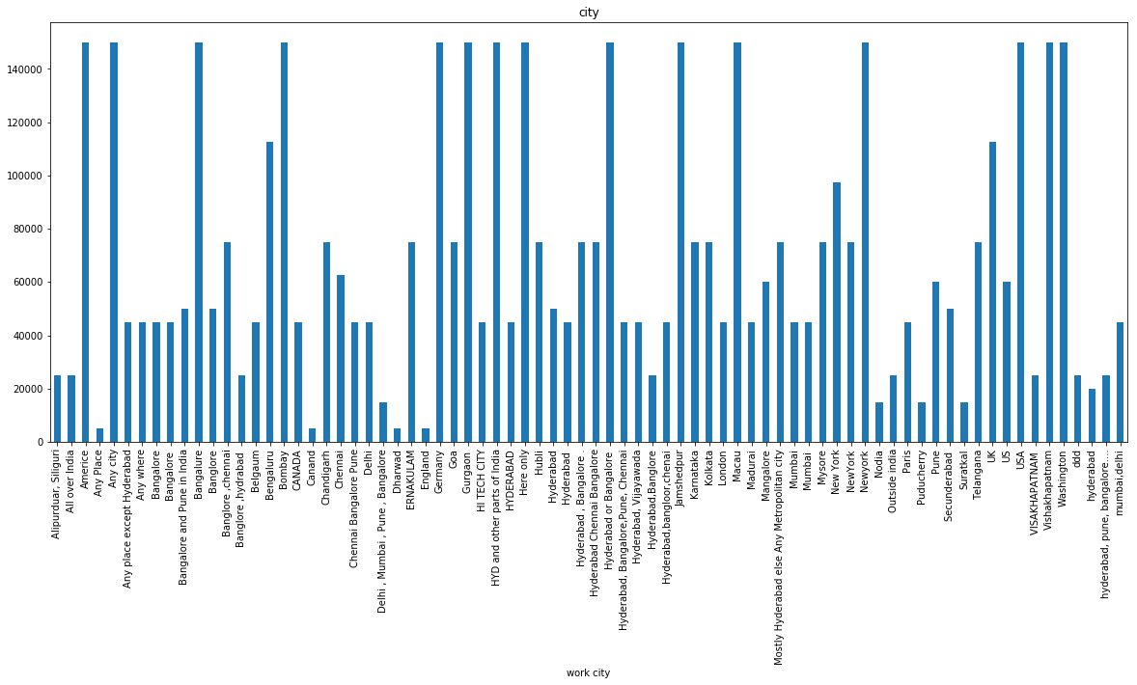

From above Data we can analysis that

*People who want to work in other Country expects more Salary*

*People who want to works in their place Expects less Salary*

**Preferred job industry by stream**

|  | **Commerce** | **Science** | **Engineers** | **Arts** | **other** |
| --- | --- | --- | --- | --- | --- |
| **Field to work in** |  |  |  |  |  |
| **Anything related to machine learning/AI AI can be applied in any of the above options** | 0 | 0 | 1 | 0 | 0 |
| **Automobile** | 0 | 0 | 1 | 0 | 0 |
| **Designing And Cloud Computing** | 0 | 0 | 1 | 0 | 0 |
| **Electrical** | 0 | 0 | 1 | 0 | 0 |
| **Electrical related core company** | 0 | 0 | 1 | 0 | 0 |
| **Finance** | 4 | 2 | 2 | 0 | 0 |
| **Health care** | 1 | 5 | 1 | 1 | 0 |
| **Healthcare** | 1 | 3 | 3 | 2 | 0 |
| **IT & Software** | 2 | 8 | 78 | 5 | 0 |
| **Information Technology** | 0 | 2 | 2 | 1 | 0 |
| **Manufacturing** | 4 | 3 | 11 | 5 | 0 |
| **Marketing** | 7 | 2 | 9 | 7 | 0 |
| **Media** | 1 | 0 | 8 | 2 | 0 |

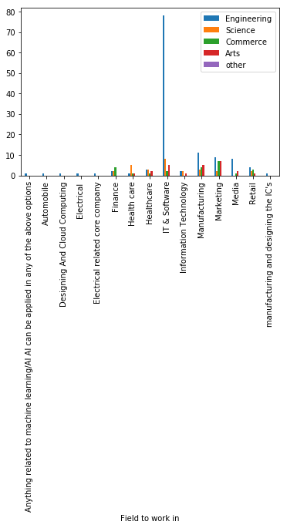

By this we come to know that

Engineers are more interested in IT &Software sector and marketing

Commerce students are more interested in marketing

Arts students are more interested in marketing

**Preferred salary by college tier**

College

Alur venkta roa 25000.0

BITS PILANI HYB CAMPUS 75000.0

BVB 75000.0

Basel Mission 45000.0

Basel mission 15000.0

Bms 75000.0

Bms 75000.0

CVR College of engineering 45000.0

Ellenki institute of engineering and technology 25000.0

GIT 50000.0

Geethanjali College of Engineering and Technology 45000.0

Googte 150000.0

Govt College 30000.0

Haliyal 45000.0

JSS 45000.0

Jnnc 45000.0

KCD 60000.0

KITE 75000.0

KLE 75000.0

KLEIT 75000.0

Karavali institute of technology 45000.0

Kcd 45000.0

Keshav Memorial Institute of Technology 150000.0

MGIT 25000.0

MVSR ENGINEERING COLLEGE 45000.0

MVSR engineering college 45000.0

Mallareddy Engineering college for women's 150000.0

Mallareddy engineering college for women 45000.0

New Pragathi college of commerce and science 25000.0

Nmam 50000.0

V.S.M. college of engineering,Ramachandrapuram. 25000.0

VARDHAMAN COLLEGE OF ENGINEERING 45000.0

VDRIT 75000.0

VIGNANA BHARATHI INSTITUTE of TECHNOLOGY 45000.0

VNR VJIET 75000.0

VSM college of engineering,Ramchandrapuram 25000.0

Vaagdevi college of engineering 75000.0

Vardhaman 150000.0

Vardhaman College 45000.0

Vardhaman College Of Engineering 75000.0

Vardhaman College of Engineering 45000.0

Vardhaman College of Engineering 45000.0

Vardhaman College of Engineering. 45000.0

Vardhaman College of engineering 75000.0

Vardhaman college 150000.0

Vardhaman college of Engineering 45000.0

Vardhaman college of engineering 45000.0

Vardhaman college of engineering 50000.0

Vardhman college of engineering 150000.0

Vbit 25000.0

Vidyasagar University 25000.0

Vignana Bharathi Institute of Technology 50000.0

Vignana Bharathi institute of technology 60000.0

Vsm college of engineering 45000.0

Vsm college of engineering 45000.0

Y. N. Degree college 25000.0

institute of aeronautical engineering college 15000.0

kle 25000.0

other 75000.0

siddhartha institute of science and technology 25000.0

F

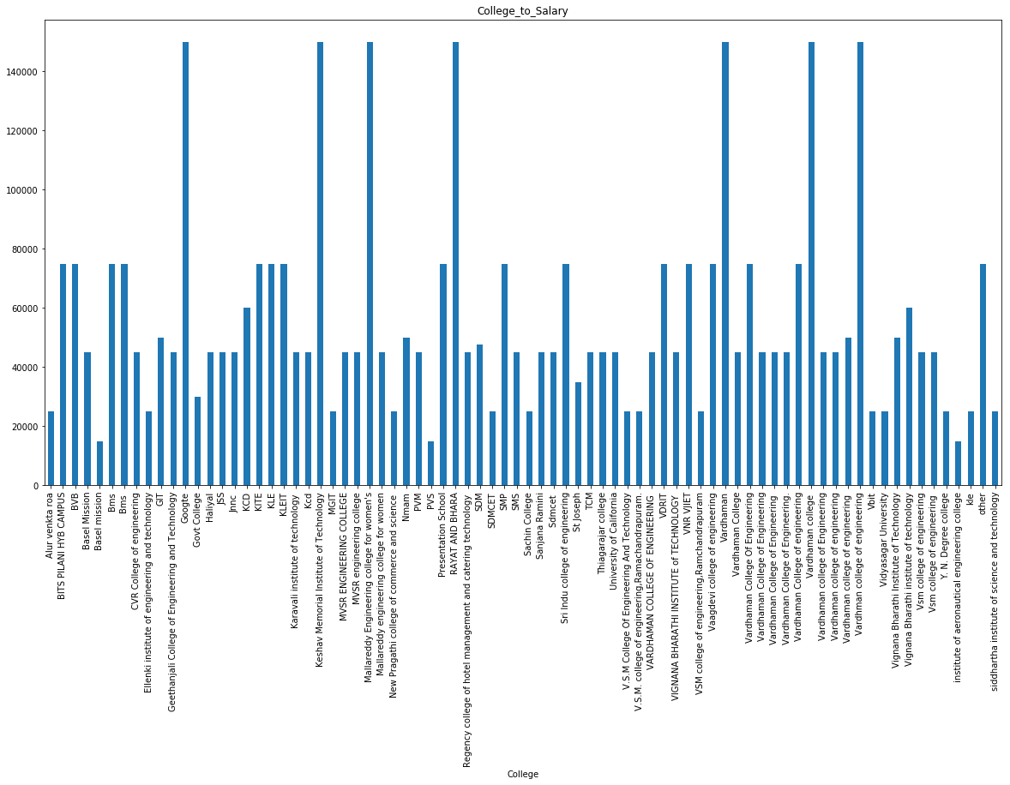

From this we can come to know that

* Vardhaman college and googte college students expects more salary
* Alur Venket Rao college expects less Salary

**Percentage of permanent job seekers vs those interested in entrepreneurship?**

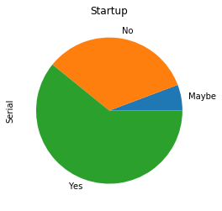

* More than 60% are interested in Startup
* 30% are seeking for permanent job
* 10% people are in confuse state

**Which city shows more tilt to entrepreneurship vs fixed job?**

* 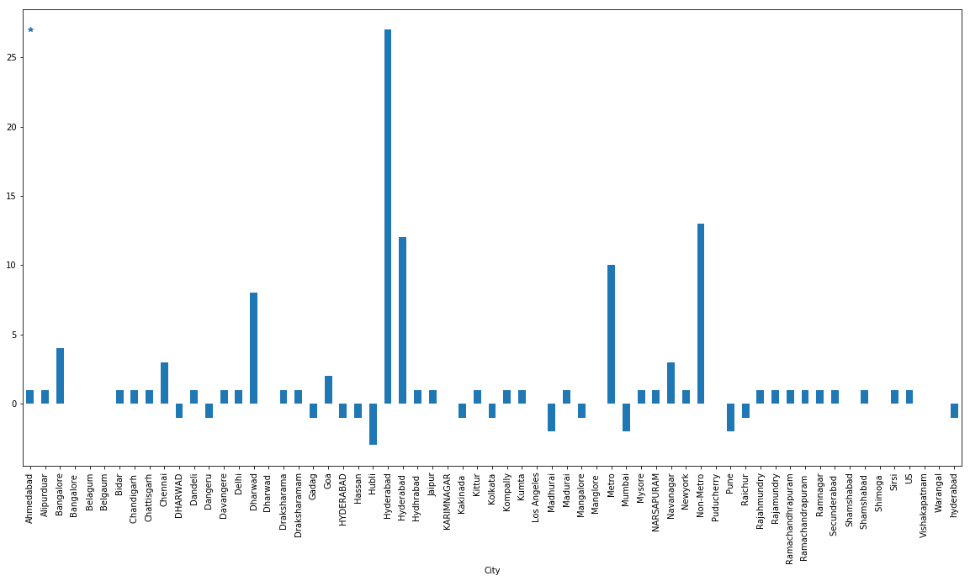Hyderabad,New York and Dharwad People are more interested to startup
* Kittur,Pune and other small place people seek for permanent Job

**Job role to stream**

|  | **IT & Software** | **BPO** | **Mechanical** | **HR** | **other** |
| --- | --- | --- | --- | --- | --- |
| **Stream** |  |  |  |  |  |
| **Arts** | 8 | 13 | 0 | 14 | 19 |
| **Commerce** | 7 | 13 | 0 | 18 | 25 |
| **Engineering** | 84 | 9 | 1 | 21 | 47 |
| **Science** | 10 | 12 | 0 | 11 | 31 |
| **other** | 0 | 0 | 0 | 0 | 1 |

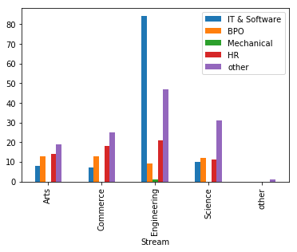

* Arts students works in all the field other than Mechanical
* Commerce students works as more as HR
* Engineers works in IT field more
* Science students are interested in other field rather than IT

**College tier to role mapping**

|  | **IT & Software** | **BPO** | **Mechanical** | **HR** | **other** |
| --- | --- | --- | --- | --- | --- |
| **College** |  |  |  |  |  |
| **Alur venkta roa** | 2 | 0 | 0 | 0 | 0 |
| **BITS PILANI HYB CAMPUS** | 1 | 0 | 0 | 0 | 0 |
| **BVB** | 2 | 3 | 0 | 7 | 8 |
| **Basel Mission** | 1 | 2 | 0 | 7 | 0 |
| **Basel mission** | 0 | 2 | 0 | 1 | 0 |
| **Bms** | 0 | 0 | 0 | 3 | 3 |
| **Bms** | 1 | 0 | 0 | 0 | 0 |
| **CVR College of engineering** | 1 | 0 | 0 | 0 | 0 |
| **Ellenki institute of engineering and technology** | 1 | 0 | 0 | 0 | 0 |
| **GIT** | 1 | 3 | 0 | 2 | 5 |
| **Geethanjali College of Engineering and Technology** | 1 | 0 | 0 | 0 | 0 |
| **Googte** | 1 | 0 | 0 | 0 | 0 |
| **Govt College** | 0 | 0 | 0 | 2 | 0 |
| **Haliyal** | 3 | 2 | 0 | 0 | 0 |
| **JSS** | 2 | 6 | 0 | 7 | 8 |
| **Jnnc** | 1 | 0 | 0 | 0 | 0 |
| **KCD** | 3 | 0 | 0 | 3 | 0 |
| **KITE** | 1 | 0 | 0 | 0 | 0 |
| **KLE** | 0 | 2 | 0 | 3 | 4 |
| **KLEIT** | 2 | 5 | 0 | 2 | 0 |
| **Karavali institute of technology** | 1 | 0 | 0 | 0 | 0 |
| **Kcd** | 1 | 0 | 0 | 1 | 0 |
| **Keshav Memorial Institute of Technology** | 0 | 0 | 0 | 0 | 1 |
| **MGIT** | 1 | 0 | 0 | 0 | 0 |
| **MVSR ENGINEERING COLLEGE** | 0 | 0 | 0 | 0 | 1 |
| **MVSR engineering college** | 1 | 0 | 0 | 0 | 0 |
| **Mallareddy Engineering college for women's** | 1 | 0 | 0 | 0 | 0 |
| **Mallareddy engineering college for women** | 1 | 0 | 0 | 0 | 0 |
| **New Pragathi college of commerce and science** | 0 | 0 | 0 | 0 | 1 |
| **Nmam** | 1 | 4 | 0 | 2 | 2 |
| **...** | ... | ... | ... | ... | ... |
| **V.S.M. college of engineering,Ramachandrapuram.** | 0 | 0 | 0 | 0 | 1 |
| **VARDHAMAN COLLEGE OF ENGINEERING** | 1 | 0 | 0 | 0 | 0 |
| **VDRIT** | 1 | 2 | 0 | 3 | 7 |
| **VIGNANA BHARATHI INSTITUTE of TECHNOLOGY** | 1 | 0 | 0 | 0 | 0 |
| **VNR VJIET** | 1 | 0 | 0 | 0 | 0 |
| **VSM college of engineering,Ramchandrapuram** | 0 | 0 | 0 | 1 | 0 |
| **Vaagdevi college of engineering** | 0 | 0 | 0 | 0 | 1 |
| **Vardhaman** | 0 | 0 | 0 | 0 | 1 |
| **Vardhaman College** | 1 | 0 | 0 | 0 | 0 |
| **Vardhaman College Of Engineering** | 0 | 0 | 0 | 0 | 1 |
| **Vardhaman College of Engineering** | 2 | 0 | 0 | 0 | 2 |
| **Vardhaman College of Engineering** | 2 | 0 | 0 | 0 | 1 |
| **Vardhaman College of Engineering.** | 1 | 0 | 0 | 0 | 0 |
| **Vardhaman College of engineering** | 1 | 0 | 0 | 0 | 0 |
| **Vardhaman college** | 0 | 0 | 0 | 1 | 0 |
| **Vardhaman college of Engineering** | 1 | 0 | 0 | 0 | 0 |
| **Vardhaman college of engineering** | 18 | 0 | 0 | 1 | 8 |
| **Vardhaman college of engineering** | 20 | 0 | 0 | 1 | 8 |
| **Vardhman college of engineering** | 1 | 0 | 0 | 0 | 0 |
| **Vbit** | 0 | 0 | 0 | 0 | 2 |
| **Vidyasagar University** | 1 | 0 | 0 | 0 | 0 |
| **Vignana Bharathi Institute of Technology** | 1 | 0 | 0 | 0 | 0 |
| **Vignana Bharathi institute of technology** | 2 | 0 | 0 | 0 | 0 |
| **Vsm college of engineering** | 2 | 0 | 0 | 0 | 0 |
| **Vsm college of engineering** | 4 | 0 | 0 | 0 | 0 |
| **Y. N. Degree college** | 0 | 0 | 0 | 0 | 1 |
| **institute of aeronautical engineering college** | 1 | 0 | 0 | 0 | 0 |
| **kle** | 0 | 1 | 0 | 0 | 0 |
| **other** | 2 | 1 | 0 | 1 | 39 |
| **siddhartha institute of science and technology** | 1 | 0 | 0 | 0 | 0 |

* Vardhman College produces more Engineers every year
* BVB and basel Mission College produces HR more every year.
* JSS,KLE produces BPO more

**Conclusion:**

* Number of Engineers is more than commerce and Arts, So Salary expected is less for Engineers.
* Most of the Engineers work in IT company with the 50000 salary per month
* Number of arts students is less.
* Most of them want to startup those who lives in Metro cities and ubran area.
* People who live in rural area seek for permanent Job
* Commerce students works in marketing field more.
* Commerce students works as HR more
* Commerce students expect salary of 55000 Rs per month
* Students are more interested to join engineering